Q1.
Answer is A.

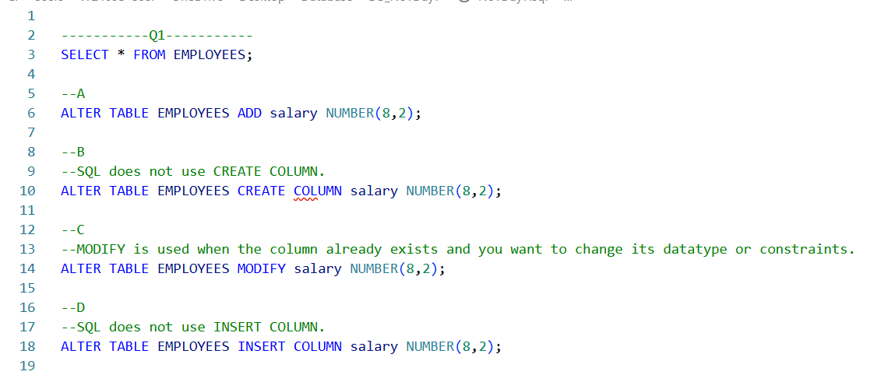

A: Correct. Standard SQL.

B: Incorrect. SQL does not use CREATE COLUMN.

C: Incorrect. MODIFY is used when the column already exists and you want to change its datatype or constraints.

D: Incorrect. SQL does not use INSERT COLUMN.

Q2.
Answer is A.

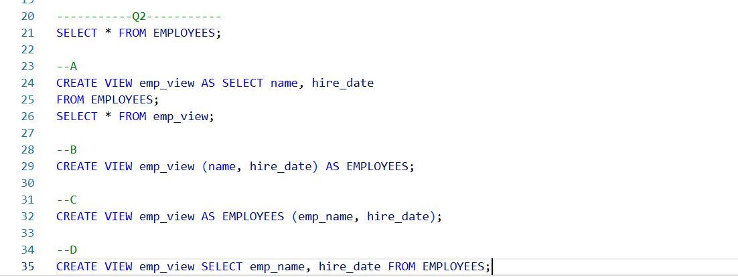

A: Correct. Valid SQL syntax.

B: Incorrect. Invalid SQL, it does not include a SELECT statement.

C: Incorrect. invalid syntax.

D: Incorrect. Missing the keyword AS.

Q3.
Answer is A.

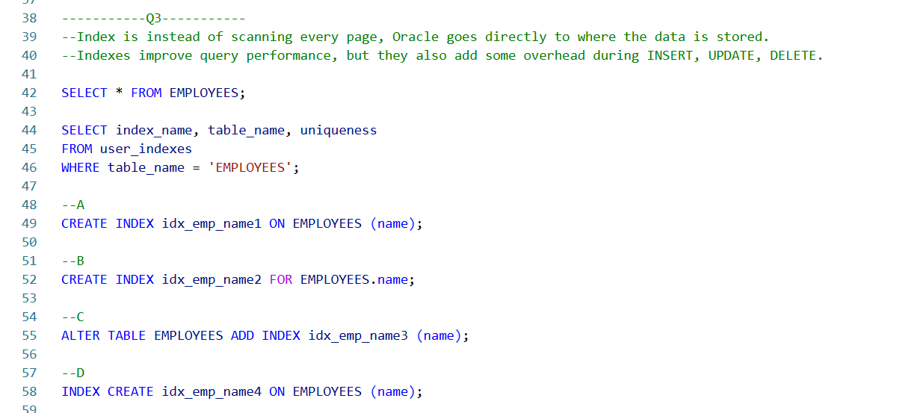

Index is instead of scanning every page, Oracle goes directly to where the data is stored.
Indexes improve query performance, but they also add some overhead during INSERT, UPDATE, DELETE.

A: Correct. correct syntax in Oracle SQL.

B: Incorrect. Oracle SQL does not use the keyword FOR when creating indexes.

C: Incorrect. Oracle does not support creating indexes using ALTER TABLE ... ADD INDEX.

D: Incorrect. INDEX CREATE is not a valid SQL keyword order.

Q4.
Answer is A.

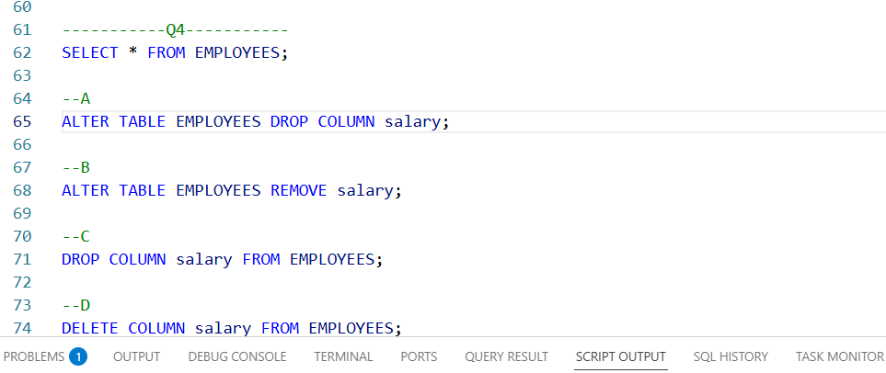

A: Correct. valid and executable SQL.

B: Incorrect. REMOVE is not valid syntax

C: Incorrect. SQL syntax does not allow DROP COLUMN to come before FROM.

D: Incorrect. SQL uses DELETE only for deleting rows, not columns.

Q5.
Answer is A.

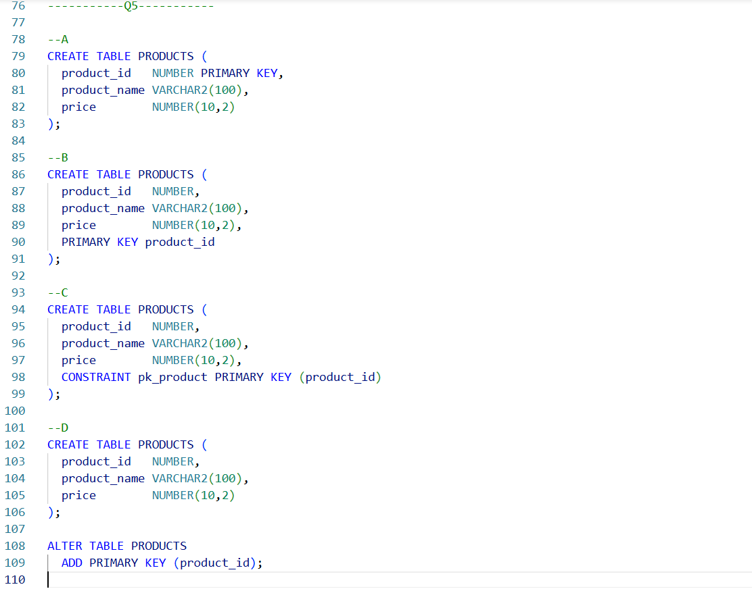

A: Correct. This is valid and correctly creates the table with a primary key.

B: Incorrect. PRIMARY KEY product_id (without parentheses) is invalid syntax in Oracle.

C: Also correct. Functionally same as A, but with a custom constraint name.

D: Also correct. it just does the job in two steps instead of one.

Q6.
Answer is A.

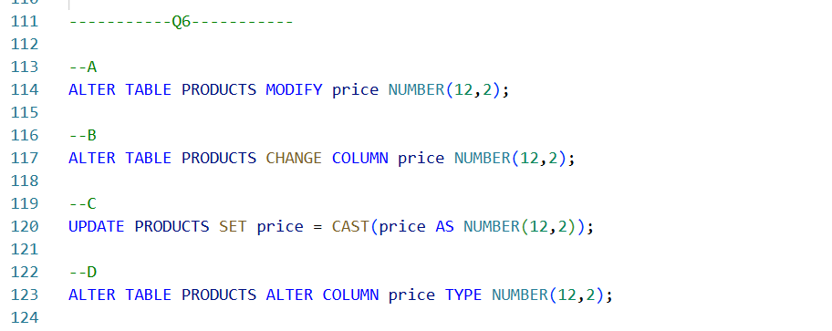

A: Correct. This is correct syntax for updating price column datatype in Oracle.

B: Incorrect. Oracle does not use the CHANGE COLUMN syntax.

C: Incorrect. UPDATE only changes the value stored inside the column, not the column definition.

D: Incorrect. This syntax matches PostgreSQL style not Oracle.

Q7.
Answer is A.

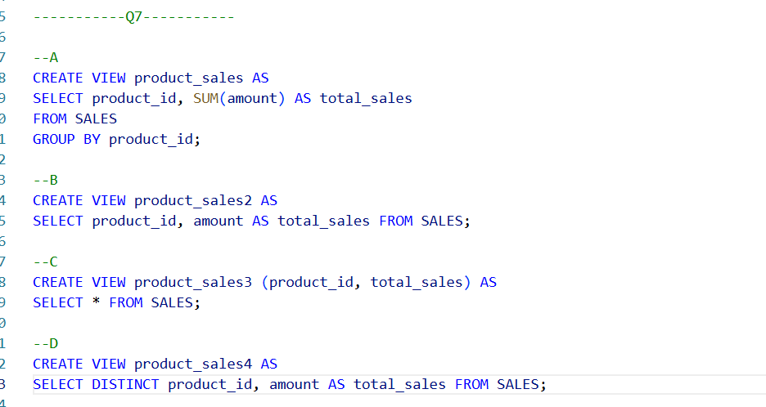

A: Correct.
SUM(amount) calculates total sales.
GROUP BY product_id ensures one row per product.

B: Incorrect. Returns all individual sales, not the total per product.

C: Incorrect. does not calculate total sales.

D: Incorrect. not computing total per product.

Q8.
Answer is A.

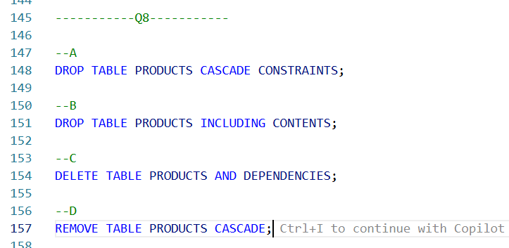

A: Correct. It is standard SQL statement.

B: Incorrect. Not valid syntax for tables in Oracle.

C: Incorrect. This is not valid SQL syntax at all.

D: Incorrect. Invalid syntax.

